St Peter’s Preschool
Tamworth Inc.

Family Information

2021
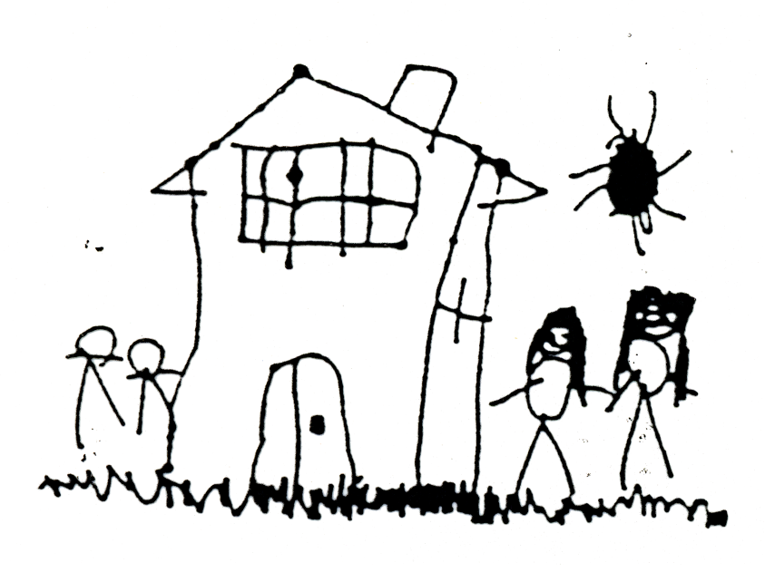

‘Playing, Learning, Growing, in a safe and caring environment.’

Welcome to St Peter’s Preschool

From the Staff and Management Committee
34 Vera Street, Tamworth
Phone: 0267657804
Mobile: 0427957804
Email: admin@stpeterspreschooltamworth.org.au
Website: www.stpeterspreschooltamworth.org.au
Like us on Facebook: St Peter’s Preschool Tamworth

St Peter’s Preschool Tamworth Inc.
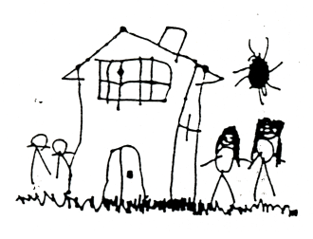

Playing, learning, growing in a safe and caring environment

Philosophy

St Peter’s Preschool believes Early Childhood Education is the foundation of learning for young children. We believe in the importance of providing access to a quality Preschool program from three years of age. St Peter’s Preschool believes that children are engaged by a sense of Belonging, Being and Becoming and works within the Early Years Learning Framework.

St Peter’s Preschool provides a safe, secure and nurturing environment with kind, compassionate and fully trained staff to meet the individual needs of each child. This is in line with the Early Childhood Code of Ethics which all staff adhere to. The aim of our Preschool is to provide an inclusive environment for all children and their families regardless of ability, multicultural background, family dynamic, religion or economic status.

Our Preschool believes it is essential to build strong, lasting, trusting relationships with all families and children whilst nurturing their individuality. Educators recognise and celebrate the important roles of both immediate and extended family. It is our belief that Early Childhood is a key period in supporting each child holistically and a time to address emerging additional needs and strengths. St Peter’s Preschool supports a balance between play based learning centred on each child’s needs, strengths and interests and intentional teaching moments. Additionally, we recognise the importance of providing creative expression experiences throughout the program.

Educators model and promote the development of confidence and self-esteem, both individually and as a member of the Preschool, and wider community. We recognise the importance of promoting positive mental health outcomes for families, children and staff. St Peter’s Preschool supports and encourage staff to engage in ongoing critical reflection and to participate in professional development.

It is part of our Philosophy to teach children about the Christian faith according to the Bible. We are committed to explaining Christian values that flow from understanding God’s love to us in Jesus such as empathy, respect, compassion and love for each other. This is demonstrated by a section of John 13:34 which states “Love one another as I have loved you” which guides our interactions with children and families. These values align with those of St Peter’s Anglican Church.
Educators are committed to instilling in all children a love of, and commitment to the care of their local, national and global environments. Sustainable practices are embedded in every day planning and learning with resources and natural materials sourced where ever possible.

St Peter’s Preschool is recognised by the local educational community for laying a strong foundation of learning that assists children in their next steps to formal schooling, which is also supported by family feedback. The Preschool values strong relationships with local services as our Preschool recognises the importance of community connections to foster a sense of belonging. St Peter’s Preschool is an advocate for Early Childhood Education and welcomes students from TAFE, Universities and schools to engage in reciprocal learning relationships.

Our Philosophy has been written and shaped by the ideas and thoughts of our Preschool children. The following statements helped shape our Philosophy. When asked why children come to Preschool the children replied, “so we can learn”, Oliver (2019), “to play”, Aiden (2019), “to make craft”, Naomi (2019), “to play with friends”, Madison (2019), “to have some fun”, Emilia (2019), “because we learn new things”, Oliver (2019), “so we can learn to play kindly and share”, Georgia (2019),
“because it is important”, Edward (2019).

(This document was modified and formerly implemented from the commencement of 2020, after consultation with parents via a survey, committee members at a general meeting, and educators and other staff after training and discussion at staff meetings)

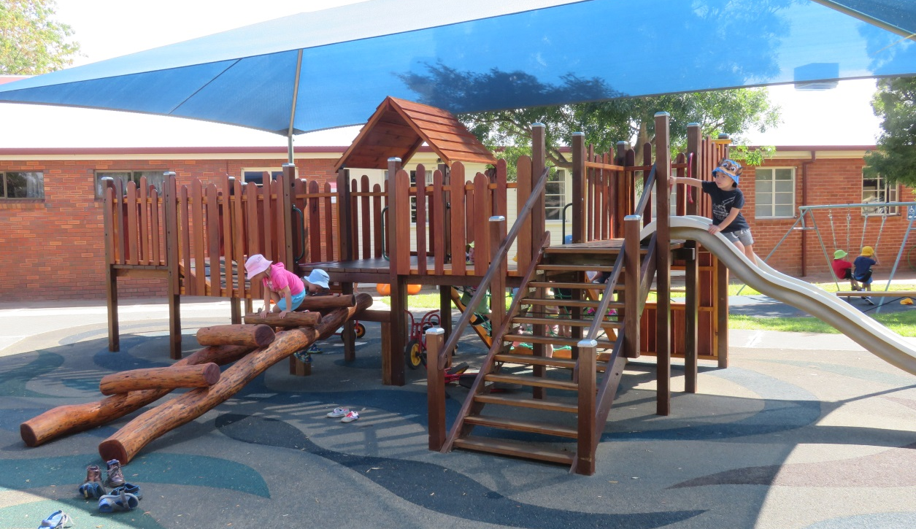

MISSION STATEMENT
St Peter’s Preschool Tamworth offers quality child-focused education and care for all children between the ages of three and five. Our fully inclusive program offers each child the opportunity to develop in all areas at their own pace. Fully trained and experienced staff and educators provide a safe, kind, caring environment for playing, learning and growing.

BACKGROUND INFORMATION

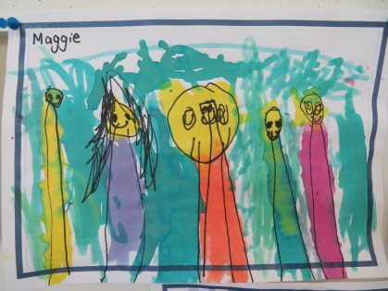
ATTENDANCE PATTERNS/SESSION TIMES:
Monday 8.30 – 4.00: 3 – 5yrs Groups
Tuesday 8.30 – 4.00: 3 – 5yrs Groups
Wednesday 8.30 – 4.00: 3 - 5yrs Groups
- Thursday 8.30 – 4.00: 3 - 5yrs Groups
Friday 8.30 – 4.00: 3 - 5yrs Groups

TERM DATES: 2021
Term 1: Thursday 28th January – Thursday 1st April 2021
Term 2: Monday 19th April – Friday 25th July 2021
Term 3: Monday 12th July – Friday 17th September 2021
Term 4: Monday 5th October – Tuesday 14th December 2021

EDUCATORS – TEACHER/ROOM LEADER
- Faye Rankins – Dip. Teaching Early Childhood (Teacher) Mon/Tue.
(Wed/Thurs: Nominated Supervisor / Administration)
- Simone Hurst – Master of Sp. Ed. with Distinction, B. Teaching/B. of Social Science (Additional Needs) Mon/Tue, (Teacher) Wed/Thurs/Fri.
- Jenny O’Toole – B. Ed E.C., B. Teaching E.C., Assoc. Dip. in Social Science - Child Studies (Educational Leader/Teacher) Mon. to Fri.

EDUCATORS - ASSISTANTS
- Eileen Stanger – Cert lll in Children’s Services (Assistant) Mon. to Fri.
- Kelly McKenzie – Dip. of Children’s Services – Centre Based Care (Assistant) Mon. to Thu.
- Megan Hawes – Cert lll in Children’s Services (Assistant) Mon. to Fri.
- Anna Jefferys – Dip. of Community Services - Children’s Services (Assistant) Mon/Tues/Wed/Fri.
- Rachel Petrie – Dip. of Children’s Services – Centre Based Care, Assoc. Dip. in Social Science - Child Studies (Assistant) Mon/Wed.
- Tracey Cook – Cert lll in Children’s Services (Assistant) Tue/Thu/Fri.
- Roma Giles – Cert ll IT (Admin Assistant) Mon/Wed/Fri.
- Suzanne O’Neil – Cert lll in Business Admin/Assoc. Dip. in Social Science - Child Studies, Cert lll in Children’s Services (Admin Assistant/Educator) Mon/Tue/Wed/Thu.
Please note: There is always an educator working directly with the children who has current first aid, anaphylaxis and asthma training.
CONDITIONS OF ENROLMENT
ENROLMENT CARD
- The enrolment card is a legal document which contains all information relevant to your child. It must be kept updated at all times and we need to know of any changes immediately.
- On enrolment, the following information is required:
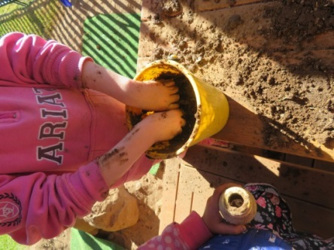
  - Completed Enrolment Card with all relevant information and signature(s)
  - ACIR Immunisation History Statement
  - $60 booking fee (non-refundable)
  - Health Care Card (if applicable)
  - Copy of the child’s Birth Certificate
- All sections of the enrolment card need to be fully completed
- If your child has any medical conditions/allergies/ asthma, it needs to be documented on the card.
  - We require a current Management Plan from your Doctor on enrolment. (speak to administrative staff if you need assistance in accessing this from your Dr.)
- If your child has additional/specific learning needs, please detail this on the enrolment card as well as providing any assessments/documentation.

IMMUNISATION
- Families enrolling at St Peter’s Preschool are required to provide proof of the child’s current age appropriate immunisation, in the form of the Immunisation History Statement available from Medicare. We are required by law to retain a copy of this information. This must be provided with the initial enrolment card or enrolment cannot proceed.
- If your child is NOT immunised, and you do not have the required documentation your child will be excluded from St Peter’s Preschool as required by the Public Health Amendment (Vaccination of Children Attending Child Care Facilities) Act 2013.

BOOKING FEE
A non-refundable annual $60 Booking Fee is paid to secure your child’s place at the preschool before the starting date. (On initial enrolment, your child will receive a Preschool hat, and in the second year they will receive a Preschool drink bottle).
If you have not previously notified the preschool of absences on commencement, the position may be forfeited.

PRESCHOOL HOURS
- The preschool hours are: 8.30am to 4.00pm Monday to Friday during NSW public school terms.
Morning Drop Off
- Due to licensing requirements we are unable to allow families into the building until 8:30am.
Afternoon Pick Up
- St Peter’s Preschool closes at 4.00pm. Please be here to collect your child before this time so your family is exiting the building no later than 4pm.
- Please note, if your child is still present after 4.00pm, a fee of $15.00 for any part of the first 15 minutes will be charged. (This will increase to $30 for the next 15 minutes, etc).

SIGN IN SIGN OUT
- Each child must be brought into the Preschool and signed in by their parent or carer at the sign in area in the child’s room. Responsibility cannot be accepted where children are left to make their own way into the care of the staff.
- Each child must be signed out by a parent or carer at the end of the session.
- Staff must be informed if a child is to be picked up by any other person except the parents, carer or other nominated person. If a person who is not listed on the enrolment card is collecting the child, written permission needs to be given, or in an extreme case, a phone call made to notify staff. This person will be asked to produce identification.
- The children are divided into two groups according to attendance patterns to ensure consistency as much as possible.
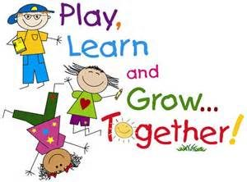
- The children will be in mixed age groupings across each day of the week.
- Groups:
  - Bilby group – Monday to Friday in the Preschool room closest to the church
  - Platypus group – Monday to Friday in the Preschool room closest to the preschool offices

FAMILY INFORMATION AND NEWSLETTER
A preschool newsletter is emailed to every family on two occasions each term. (If you do not have an email address, we will provide you with a paper copy.). In addition there will always be a copy displayed in the information cabinet on the verandah. In order for you to be aware of what is happening at St Peter’s Preschool, it is essential that you take the time to read them.

WHAT YOUR CHILD WILL NEED
Backpack which includes:
- Hat: large brimmed, bucket-style (no caps)
- Hand towel (optional)
- Paint apron or old shirt for creative activities
- Lunch and afternoon tea in labeled container with frozen ice brick
- 1 large water bottle (can be half frozen in summer)
- Changes of clothes
If you child will require a rest / sleep, two cot sheets and bassinet sized pillow, in a fabric/drawstring bag
NB: Preschool shirts and hats are available on request.

PLEASE CHOOSE HEALTHY FOODS
Morning Lunch – sandwiches, rolls or wraps with a healthy filling, or a salad, pasta, baked beans and water to drink. (Please note: we are unable to reheat food, due to variations in heating temperatures in microwaves, and to do this means removing a staff member from supervision of the children. Some families bring heated food in a thermos flask).
Afternoon Tea - Fresh fruit (in portions your child can manage), fresh vegetables, dried fruit, cheese pieces and/or plain cracker biscuits, plain yoghurt (with a spoon) and water to drink.
(Avoid foods that contain added fats or sugars, additives, preservatives or flavours, or food that sticks to the teeth, e.g. fruit sticks, muesli bars).
We have a booklet available called ‘Balancing the lunchbox’ issued by NSW Government Health. This includes ideas and suggestions.

WE ARE A NUT FREE PRESCHOOL

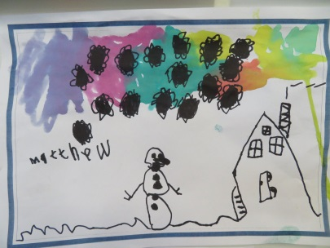
CLOTHING
St Peter’s Preschool is a Cancer Council ‘Sunsmart’ service, meaning we promote safe and ‘Sunsmart’ policies and practices. It is expected that your child will arrive at Preschool in appropriate, sun safe, comfortable clothing and footwear.
Tops which cover the neck, shoulders, upper arms and back (no strappy singlet tops or dresses) and shorts/skirts/long pants which are comfortable and promote movement.
Hats which cover the entire face, ears and neck – such as wide brimmed, bucket style or legionnaires.
Shoes which are secure and non-slip and attach in some form; straps, Velcro, laces, buckles (no thongs or slip-ons, as they can be dangerous during movement or physical activity).

PLEASE LABEL EVERYTHING
ADDITIONAL INFORMATION
- Qualified and careful supervision of the children is maintained, but the Preschool and teachers cannot be held responsible for accidents which may occur. In the event of injury, the staff reserves the right to call in medical advice if considered necessary.
- If any child is too ill to remain at preschool the parent will be contacted and arrangements made for the child to be taken home, as listed in the relevant policies. This assists our Preschool to minimise the spread of infection.
- Do not send your child to Preschool when they are unwell. This includes:
  - having a loose cough or,
  - thick discharge from the nose,
  - temperature, vomiting or diarrhoea within the 24 hours before Preschool or
  - requires medication (paracetamol or cough mixture), in the morning.
- If your child is absent or away due to illness or family holidays, there are no opportunities to make up these days at another time.
- At all times parents need to be aware of safety in the car park. Hold your child’s hand and ensure no other child walks through the gate as you are arriving or leaving. No child under the age of 12yrs should be left unattended in a car whilst you collect your Preschool child.
- The minimum age of children for enrolment is three years and each child needs to be moving toward being toilet trained. The preschool reserves the right to temporarily discontinue an enrolment at any time.
- If a child is to be withdrawn from preschool, two (2) week’s advance notice must be given and fees paid for those weeks.
- You are able to collect your child any time after 3pm at a time which suits your family as the children will be involved in free play activities at this time. As long as your family is leaving by 4pm.
- Fire and lockdown drills are carried out with each group on each day of the week once per term.
- Please apply sunscreen each morning before arriving or access the Preschool supply on the sign-in tables or outside near the bag hooks.
  - Staff assist children to self-apply sunscreen before outdoor play sessions.
- Excursions may be carried out relating to the interests of the children throughout the year.
- Speak positively about preschool - always be enthusiastic.
- Remember it is normal for your child to be distressed when you leave for the first time, or it is normal if they don’t – expect either
- Always feel free to chat to a staff member at any time about anything. If they are unable to talk at the time, please make an appointment. You are welcome to call or email the preschool at any time.

MANDATORY REPORTERS
- St Peter’s Preschool staff are required by law to report any risk of significant harm to any child within our care.
- Reports are made to the Department of Family & Community Services or other relevant agencies.

MANAGEMENT COMMITTEE
St Peter’s Preschool is a community-based Preschool Education and Care Service. It is an outreach of St Peter’s South Tamworth Anglican Church and as such its constitution stipulates that the vicar of the church, or his delegate, is the president of the management committee. The remainder of the committee is made up of three parent representatives and two other members of St Peter’s Anglican Church. Each year a new Management Committee is elected at the Annual General Meeting held in March.
If you are interested in being a member of the committee, we would welcome your involvement. Please see a staff member if you would like to take an active role in the management of St Peter’s Preschool.
(Please note when your child has finished attending St Peter’s Preschool, you can no longer be an active member.)

POINTS TO REMEMBER
- If you have any concerns about your child at any time, please do not hesitate to talk to your child’s teacher. We are here to assist you in any way we can and we will also discuss their achievements and triumphs with you.
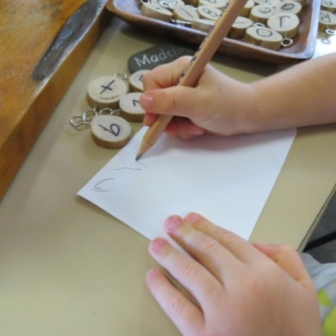
You can email the Preschool on: admin@stpeterspreschooltamworth.org.au

- We are able to refer children to a variety of professional services in Tamworth, e.g. hearing, speech pathology, occupational therapy and early intervention. In addition we work closely with a number of local schools during transition for our older ‘school ready’ children.

- If any items come home in your child’s bag and they are not yours, please return them as soon as possible. Lost property is kept for six weeks, and then donated to charity.

- If you would like to make a complaint, please ask staff in person or via email for a copy of the ‘Handling Complaints Policy’ which outlines the correct procedure. You are more than welcome at any time to discuss matters arising with the Nominated Supervisor to resolve any issues where possible, or take the matter to the Management Committee.
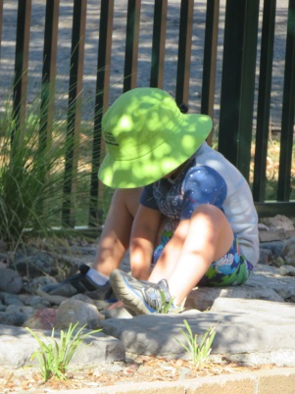
PAYMENT OF FEES
St Peter’s Preschool is a community based Preschool. As such we rely on parents commencing and finalising payment of fees by the due date each term.
Our fee payment system is automated in the following sequence:
- Week 1: invoice is generated to commence from the beginning of term based on income level information provided: received during the holidays before.
- Week 3: reminder email is generated if any fees remain outstanding
- Week 4 & 5: reminder email is generated unless fees have been finalised
- Week 6: a reminder email is made to follow up non-payment
- Week 7: a reminder email (or letter) is generated pending legal action
- Week 8: a formal letter is sent notifying that legal action is imminent: (all costs will be incurred by you).
Fee payment options are listed below:
- Fees can be paid with your credit card using the ‘Pay now’ feature on your invoice or reminder email.
- Fees can be paid by direct deposit into the Preschool bank account
- Fees can be paid by requesting the set up of a direct debit schedule that suits you, using the IntegraPay system. Please complete a form at the Preschool administration office.
  - We will require a clear print of your account name, BSB & account number from your statement or transaction report.
- Fees can be paid by placing cash in the envelopes provided & giving to staff member.
It is expected that fees will be finalised by the end of Week 8 of each term. Your child will not be able to return the following term until the previous terms’ fees are settled.
The Management Committee has determined that if any part of your child’s fees is still outstanding by the end of Week 8 in Term 4 the following will occur:
- they will not receive their portfolio of learning, and
- the children going to school will not be part of the certificate presentation at the end of year celebrations.
- they will be unable to return to Preschool from Week 9
Bank details are included on each invoice, and are listed below:
- ANZ Account name: St Peter’s Preschool Tamworth Inc.
- BSB: 012 830 Account number: 208234965

If you feel you are eligible for a subsidy, a current Health Care Card must be provided. Notify changes of income immediately.
Fees are not refundable when absences occur, to ensure the child’s place is maintained.
If a child is to be withdrawn from preschool, two (2) week’s notice must be given and fees paid for those weeks.
POLICIES
St Peter’s Preschool has policies on the following aspects as per the Education and Care Service National Regulations.

Acceptance and refusal of authorisation | Information technology
Access | Interactions and relationships with children
Administration of first aid | Medical conditions
Administration of medication | Medical conditions risk minimisation plan
Arrival and departure | Physical activity
Bushfire | Physical environment
Child health, hygiene and infection control | Positive behaviours
Child protection | Professionalism and code of conduct
Cleaning and maintaining the environment | Providing a child safe environment
Clothing and footwear | Records and retention of records
Communication with families | Risk management procedures
Compassionate leave | Road safety
Complaints and feedback | Routines
Confidentiality and privacy | Safe sleep and rest time
Coronavirus | Staffing arrangement
Determining responsible person | Storage of dangerous substances
Educational program and practice | Sun protection
Emergency / evacuation | Supervision
Enrolment and orientation | Systems review
Environmental sustainability | Toileting
Excursion | Transition to school
Family behaviour | Visitors
Fees | Volunteers and students
Food and nutrition | Water safety
Governance and service management | Work health and safety
Head lice | Works completed
Immunisation and infectious diseases
Incident, injury, trauma and illness

All families are encouraged to familiarise themselves with the policies. The policy folder is located on the bench in the Bilby room at all times, or alternatively, any policy can be emailed on request.
If you have any questions or comments, please contact the preschool.

DAILY ROUTINE

8.30-9.30am Staff arrive, and begin preparing for learning across the day
Early children start to arrive
Staff greet families and children
Outdoor/indoor activities (depending on weather conditions)
9.30-10.45am Child directed play – indoor/outdoor
10.45-11.30am Morning lunch – all children together/in smaller groups
11.30-1.00pm Group experiences & child directed play – indoor/outdoor
1.00-1.30pm Afternoon tea
1.30-2.30pm Quiet time/interest-based group learning
Opportunity for extended outdoor play (weather permitting)
2.30-3.00pm Small/whole group shared learning: language/games/story/news
3.00-4.00pm Children participating in self-directed free play
Families arrive: opportunity to chat about child’s learning
4.00pm Preschool closes

Please note: This routine is always very flexible and is only a guide, as the learning varies depending on the children, the interests, the weather, or what is happening in our neighbourhood.
The meal times mostly occur around the same time, but this can also vary.
No two days are ever the same

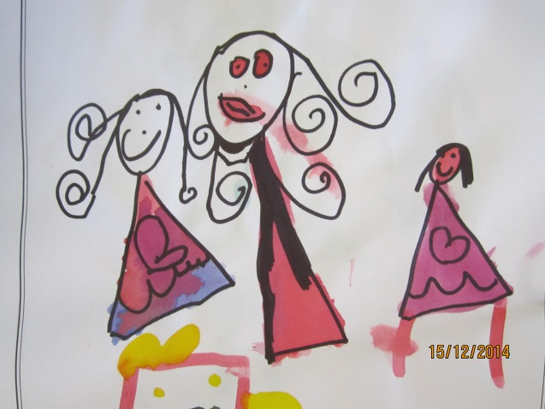

EDUCATION AND CARE SERVICES NATIONAL REGULATIONS 2011
St Peter’s Preschool works under the National Quality Standards which are under the umbrella of the National Regulations. Under the standards lies the Early Years Learning Framework which is the basis of the early learning curriculum.
Within this framework there are 5 Learning Outcomes:
- Children have a strong sense of identity
- Children are connected with and contribute to their world
- Children have a strong sense of wellbeing
- Children are confident and involved learners
- Children are effective communicators
Adapted from ‘Belonging, Being & Becoming’ the Early Years Learning Framework for Australia

Remember:
Every child is unique and will possess strengths and weaknesses in different areas. As educators our role is to enable, support and encourage the child to be the best they can be, working in partnership with you.

YOUR CHILD’S LEARNING JOURNEY
- We will continually discuss your child’s journey of learning with you and celebrate their achievements.
- During Term 3 we offer an opportunity to meet with each family individually and review their achievements and developing skills.
- We may suggest further assessment: hearing, speech, pediatrician, doctor, after discussion with you.
- Routines and consistency are important for your child’s development and confidence in the preschool setting.
- If anything changes at home: moving house, visitors, death of a pet, new baby, illness, etc., notify educators – little things can have a big impact on your child and their behaviour.

Fundamental to St Peter’s Preschool education and care is the belief that children’s lives are characterised by a sense of:
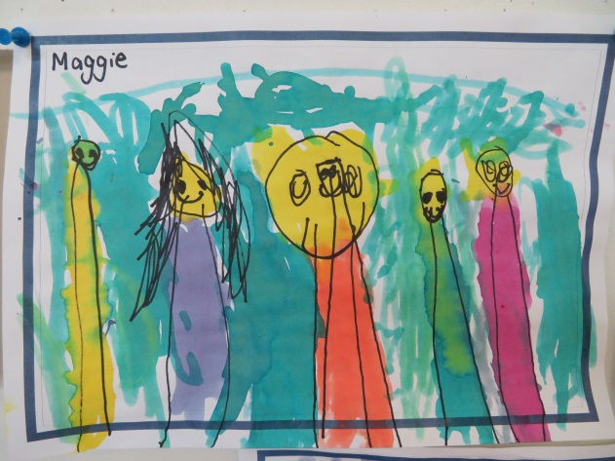
- Belonging – knowing where and with whom they belong
- Being – the here and now in their lives
- Becoming – the process of rapid and significant change as they learn and grow: learning to participate fully and actively in society
(Early Years Learning Framework)

ST PETER’S PRESCHOOL PROGRAM
Finding your Feet and Spreading your Wings
Throughout the year, depending on a child’s individual needs, strengths and abilities, they are supported and encouraged in the following aspects of Being, Belonging and Becoming:
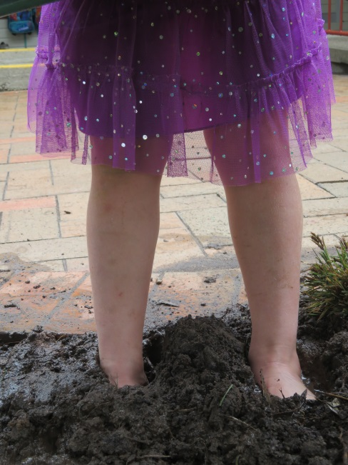
- Saying Goodbye to Mum or Dad or family member and feeling safe, secure and supported with other adults
- Interacting with others within their community
- Sharing toys, space, adults and equipment
- Waiting and taking turns and developing confidence
- Starting to become interdependent and develop resiliency
- Listening and responding to directions
- Becoming familiar with and confident in routines
- Becoming caring, empathetic members of the preschool community
- Developing autonomy and self-confidence
- Learning and appreciating differing views and opinions
- Appreciating how all children are all unique and special
- Becoming more responsible for their own physical wellbeing
- Being confident enough to create, construct, cut, paint, paste, count, sort, thread, manipulate
- Developing curiosity, cooperation, creativity, enthusiasm, persistence
- Making new friends and working with a variety of children of differing abilities
- Recognising and write their name and recognising words and sounds
- Climb, run, catch, throw, dig, sing, dance, move, play, imagine, pretend, wonder
- Looking after their own belongings and putting them back in the right place
- Experiencing and becoming familiar with pre-literacy, pre-maths and pre-science concepts – sequence, shape, volume, cause-effect, value, number, time
- Becoming more independent and self-reliant
- Saying “Stop it I don’t like it” if I need to
- Asking and answering questions, remembering and recalling things
- Making their own decisions about things, solve problems and work things out – inquiring, problem-solving, researching, investigating
- Listening to instructions and then complete tasks
- Enjoying the experience of learning

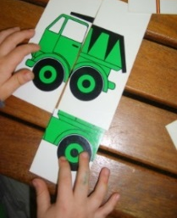
LEARNING AT PRESCHOOL
The development of thinking & learning:
Children develop through:
Thinking, problem solving, questioning, counting, sorting, experimenting, hypothesising, inventing, creating, attempting,
*****************************
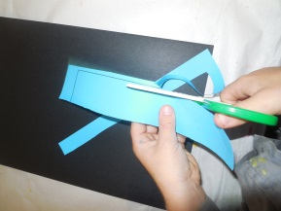
The development of small muscles. It includes the skills of eye-hand coordination, pencil grip.
Children develop through:
Drawing, cutting, threading, dough, sewing, puzzles, painting, glueing, writing, construction.

******************************

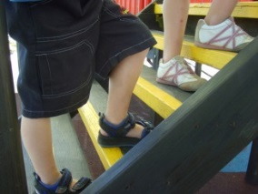
The development of large muscles.
Children develop through:
Climbing, running, jumping, swinging, riding a bike, dancing,
throwing, catching, kicking, digging, balancing.

******************************

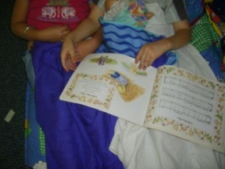
The development of language and communication:
Children develop through:
Reading books and stories, drawing, group experiences, discussions, music, listening, talking, rhymes, pictures, literacy games, sharing ideas.

******************************

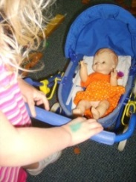
Developing a sense of belonging & learning how to be an active member of their community
Children develop through:
Socio-dramatic play, playing with friends, making friends,
group activities, sharing, taking turns, listening.

******************************
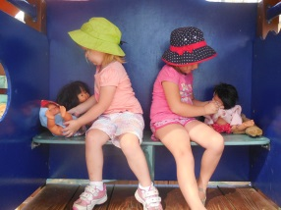
Developing a feeling of self-worth and confidence in who they are.
Children develop through: Overcoming hurdles, trying new things, mastering skills, being heard & accepted, imagining, creating, succeeding, being part of a group.
We welcome ideas, suggestions and comments and encourage you to be part of your child’s learning
and we look forward to a happy year together;
playing, learning and growing on our safe and caring environment.
If you have any gifts or talents you would like to share please see a staff member.

St Peter’s Preschool Tamworth 2021

Notes:



